**11.No of consonants and vowels**

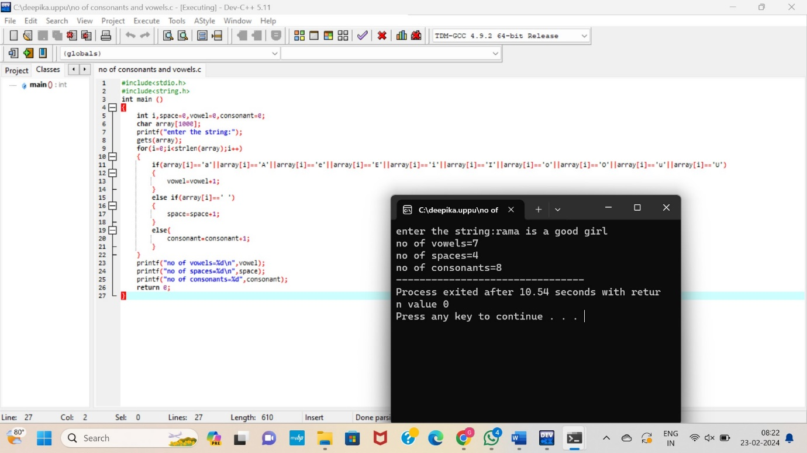

**12. Accept the Height of a Person & Categorize as Taller, Dwarf & Average**

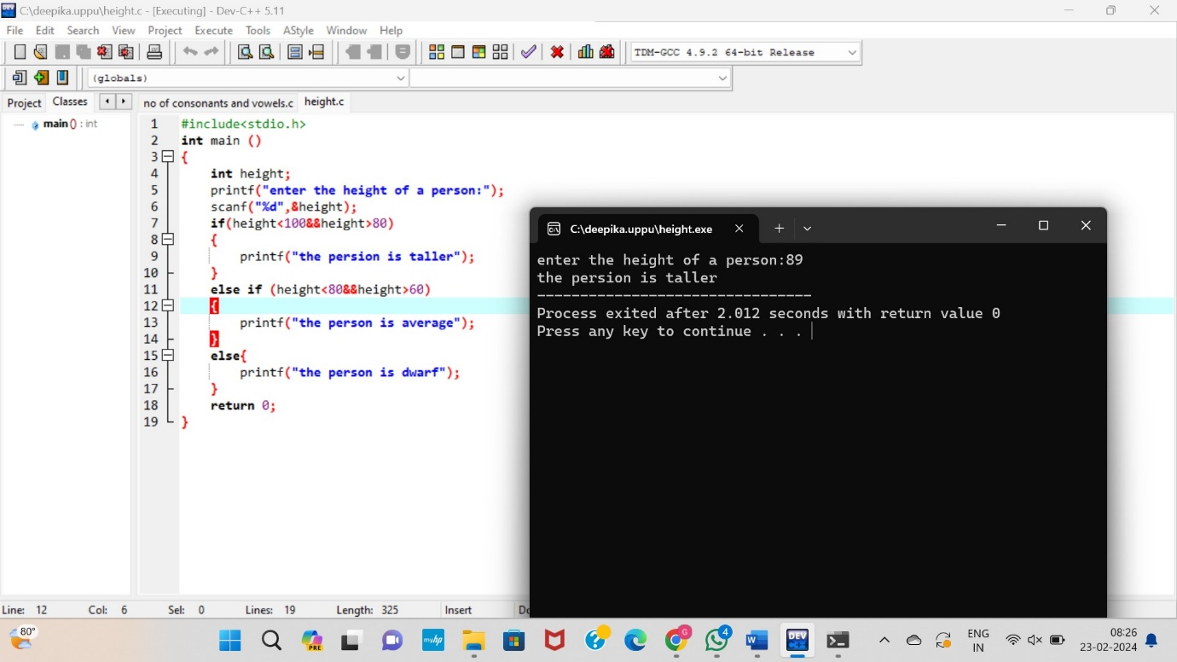

**13.Prime Number**

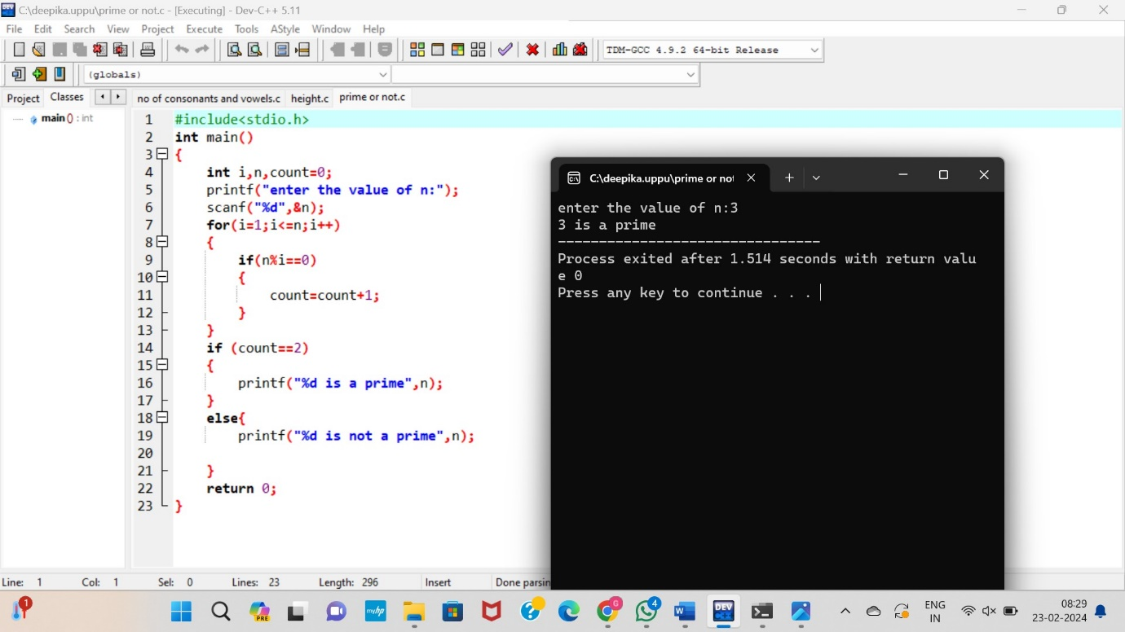

**14. Check Whether a Given Number is Perfect Number**

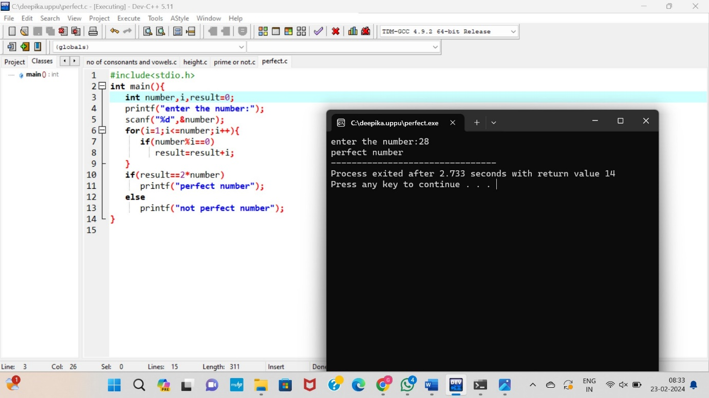

**15. Check Armstrong Number**

